`GIT DOCUMENTATION

ABOUT VERSION CONTROL

What is "version control", and why should you care? Version control is a system that records changes to a file or set of files over time so that you can recall specific versions later. For the examples in this book you will use software source code as the files being version controlled, though in reality you can do this with nearly any type of file on a computer.
If you are a graphic or web designer and want to keep every version of an image or layout (which you would most certainly want to), a Version Control System (VCS) is a very wise thing to use. It allows you to revert files back to a previous state, revert the entire project back to a previous state, compare changes over time, see who last modified something that might be causing a problem, who introduced an issue and when, and more.

Local Version Control Systems
Programmers long ago developed local VCSs that had a simple database that kept all the changes to files under revision control.
One of the more popular VCS tools was a system called RCS, which is still distributed with many computers today.RCS works by keeping patch sets (that is, the differences between files) in a special format on disk; it can then re-create what any file looked like at any point in time by adding up all the patches.

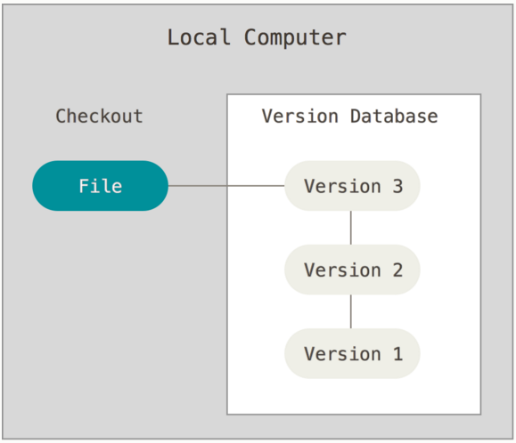

Centralized Version Control Systems
The next major issue that people encounter is that they need to collaborate with developers on other systems. To deal with this problem, Centralized Version Control Systems (CVCSs) were developed. These systems, such as CVS, Subversion, and Perforce, have a single server that contains all the versioned files, and a number of clients that check out files from that central place. For many years, this has been the standard for version control.
This setup offers many advantages, especially over local VCSs. For example, everyone knows to a certain degree what everyone else on the project is doing. Administrators have fine-grained control over who can do what; and it’s far easier to administer a CVCS than it is to deal with local databases on every client.
The main disadvantage of this type of version control is that if the central node goes down we wont be able to push changes and we lose all the data. There wont be any back up for the data.
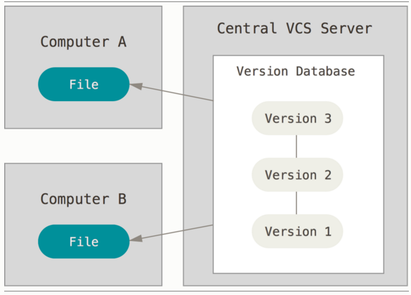

Distributed Version Control Systems
This is where Distributed Version Control Systems (DVCSs) step in. In a DVCS (such as Git, Mercurial, Bazaar or Darcs), clients don’t just check out the latest snapshot of the files: they fully mirror the repository. Thus if any server dies, and these systems were collaborating via it, any of the client repositories can be copied back up to the server to restore it.

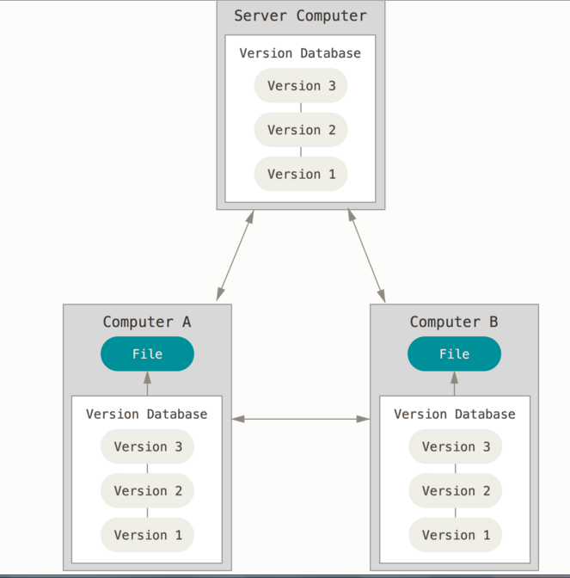

GIT HISTORY

In 2002 Linux kernel projects began using a proprietary distributed version control system(DVCS) called Bitkeeper. Then the relationship between them broke down in 2005 and Linus Torvalds decided to develop their own version control tool similar to Bitkeeper that led to the development of Git. He wanted to make sure that the tool has following features.
- Speed.
- Simple design.
- Ability to handle large projects.
- Fully Distributed.
- Non-Linear development.

GIT INSTALLATION
To install the git-bash you can find the .exe file in git-scm.com and the installing procedure is simple.
Click the downloads option in the git-scm page.
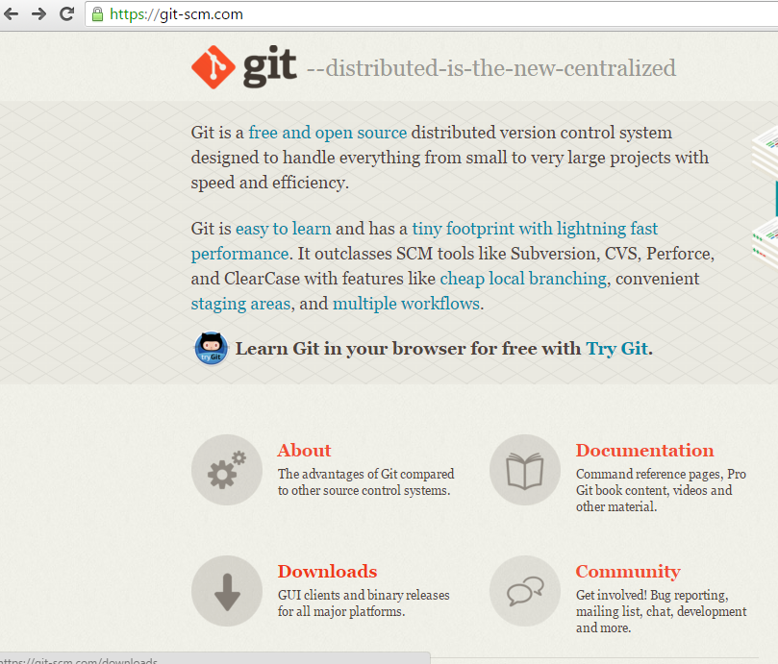

Then you can choose the operating system you are using and download the exe file.
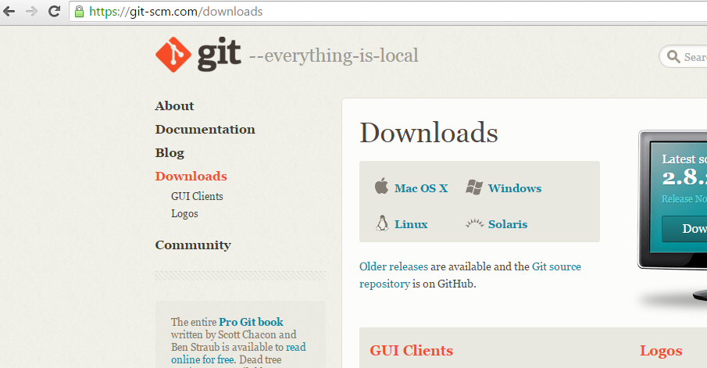
After downloading the file double click on it and follow the steps. Git bash will get installed.
While running the set-up click on check boxes 1.Git GUI here 2.Git-Bash here. 3.On the Desktop(if necessary).
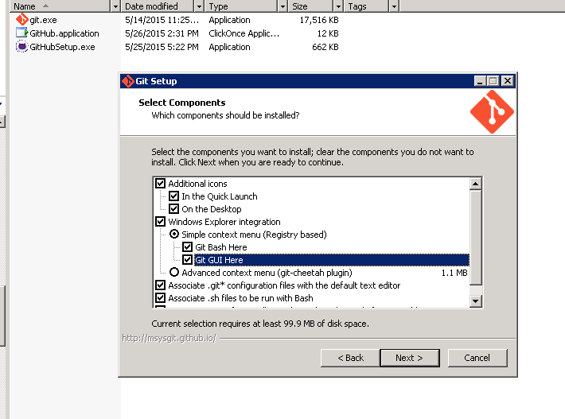

GIT BASICS

Snapshots, Not Differences
The major difference between Git and any other VCS (Subversion and friends included) is the way Git thinks about its data. Conceptually, most other systems store information and think of the information they keep as a set of files and the changes made to each file over time. Whereas Git doesn’t think of or store its data this way. Instead, Git thinks of its data more like a set of snapshots of a miniature file system. Every time you commit, or save the state of your project in Git, it basically takes a picture of what all your files look like at that moment and stores a reference to that snapshot. If files have not changed, Git doesn’t store the file again, just a link to the previous identical file it has already stored.

How other version control systems view the file.
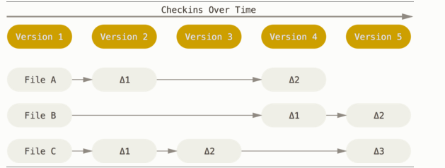
How Git views the file.
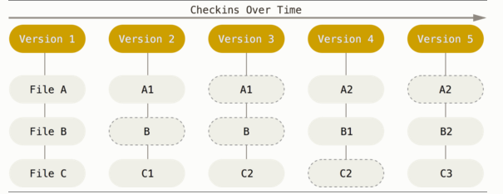

INTEGRITY
Everything in git is check summed before it is stored and is then referred to by that check-sum.
Mechanism used is SHA-1 hash code. It is a 40 character hexadecimal code which is calculated on the basis of the contents of the file or directory structure. A SHA code looks something like this
24b9da6552252987aa493b52f8696cd6d3b00373

THREE STATES

Git has three main states that your files can reside in: committed, modified, and staged. Committed means that the data is safely stored in your local database. Modified means that you have changed the file but have not committed it to your database yet. Staged means that you have marked a modified file in its current version to go into your next commit snapshot.

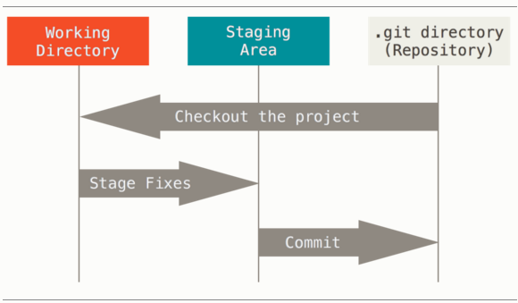
The Git directory is where Git stores the metadata and object database for your project. This is the most important part of Git, and it is what is copied when you clone a repository from another computer.
The working directory is a single checkout of one version of the project. These files are pulled out of the compressed database in the Git directory and placed on disk for you to use or modify.
The staging area is a file, generally contained in your Git directory, that stores information about what will go into your next commit. It’s sometimes referred to as the “index”, but it’s also common to refer to it as the staging area.

The basic Git work flow goes something like this:
- You modify files in your working directory.
- You stage the files, adding snapshots of them to your staging area.
- You do a commit, which takes the files as they are in the staging area and stores that snapshot permanently to your Git directory.

GIT INITIAL PROCEDURES
Initially you have to configure GIT and there are certain commands and steps you have to follow.
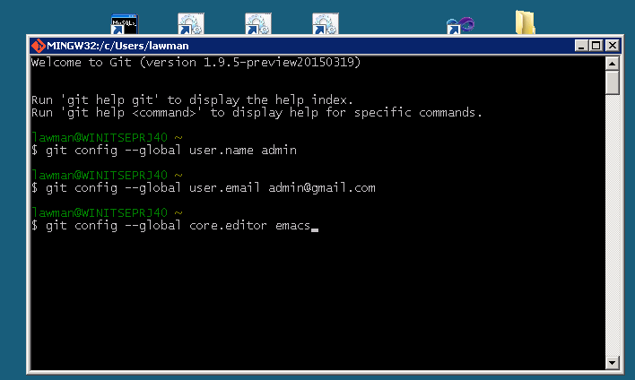

Initially you have to configure the user name and his/her respective mail id. The default editor in Git is vim editor but you can also change it by using the core.editor command.

INITIATING A REPOSITORY
To initiate a new repository where you can work with your source code git init projectname command is used.

CLONING PROJECTS
Now after initiating a repository you can either create new files of codes and commit or clone entire repository from a centralized server or a remote. The command used for that is git clone (url). You can see the two process in the below screen shot and here in cloning since I’ve used a central repo which is authenticated it asks for user-name and password.
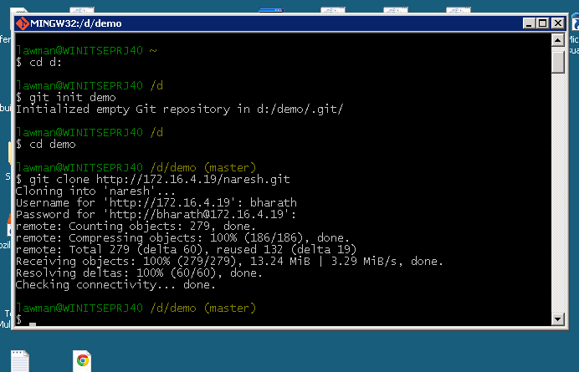
You can see that the entire repository has been cloned into your local repository for you to work.

STATUS OF A FILE
The status of a file can be viewed using the git status command but before going into that lets see the life cycle of a file in git.
Each file in your working directory can be in one of two states: tracked or untracked. Tracked files are files that were in the last snapshot; they can be unmodified, modified, or staged.

Untracked files are everything else – any files in your working directory that were not in your last snapshot and are not in your staging area.
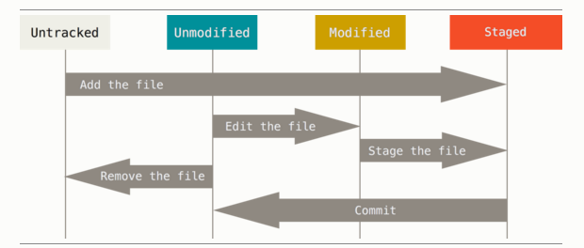

- Git status and git add
Lets say you create a new file and see the status using git status command, the status of that file will be untracked and if you perform the commit operation(explained later) the file wont get saved in your .git repo. To do so you need to add that file to the staging area by giving git add filename command.
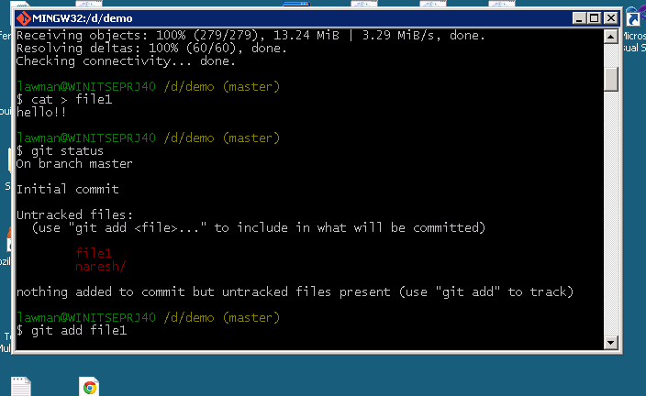
.

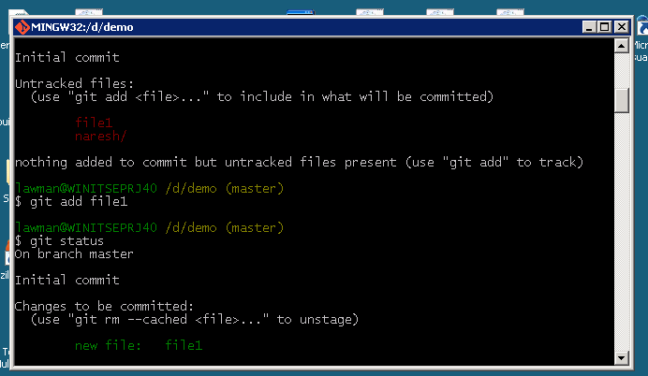
So you have given the add command also now if you see the status it will be in the staged part. That is the changes to be committed part.
Now lets say you again edit the file and check the status.
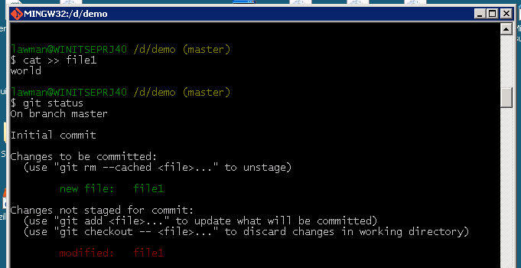
What!!! The File1 here is in both changes to be committed section and not staged for commit section too, this is because you haven’t given git add command. At this point of time if you perform the commit operation the file which is in the staged for commit section will only get committed. In case if you have to include the recent changes too you have to give git add file name command again.

Short Status
Git also has a short status flag so you can see your changes in a more compact way. If you run git status -s or git status –short you get a far more simplified output from the command:
git status -s
M README
MM Rakefile
A lib/git.rb
M lib/simplegit.rb
?? LICENSE.txt
New files that aren’t tracked have a ?? next to them, new files that have been added to the staging area have an A, modified files have an M and so on. There are two columns to the output - the left-hand column indicates the status of the staging area and the right-hand column indicates the status of the working tree. So for example in that output, the README file is modified in the working directory but not yet staged, while the lib/simplegit.rb file is modified and staged. The Rakefile was modified, staged and then modified again, so there are changes to it that are both staged and unstaged.

Ignoring Files
Often, you’ll have a class of files that you don’t want Git to automatically add or even show you as being untracked. These are generally automatically generated files such as log files or files produced by your build system. In such cases, you can create a file listing patterns to match them name .gitignore. Here is an example .gitignore file:
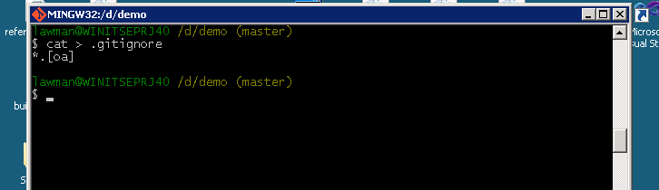
- Commit operation
This command is used to save things that are in your staging area into your .git repo. The command used is git commit and the best practice for git or any version control system is that to give a brief a log message about the commit you are performing. Git it is mandatory to give a commit message and if you give git commit alone it will enter into the vim editor to enter the message.

You can also give the commit message in the command line itself by using -m option in the commit command.
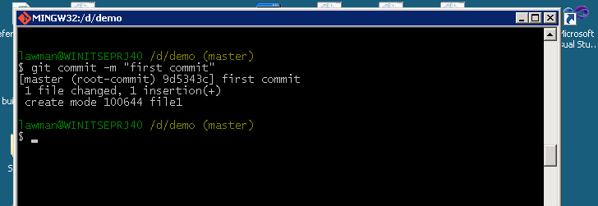
You can also skip the staging area by using -a option in the git commit command. Doing so the files in the modified section will get added to the staging area and is committed.
Note: You can use this option only for a previously committed file for a new file you have to use git add file name and then give commit.
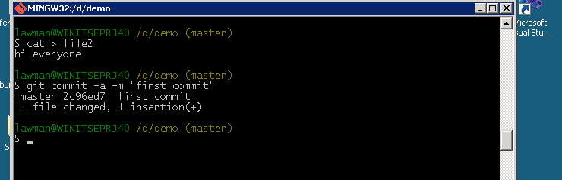
- Git diff
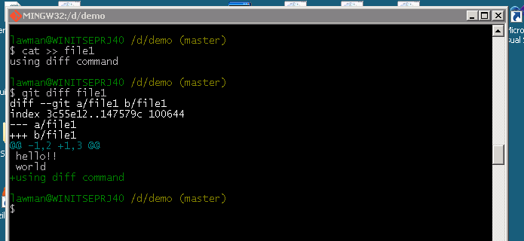
This command is used to view the difference in the file between your last commit and the same file in your present working directory. The command used is git diff filename.

You can see it is even showing the changes made to the file.
If you want to see the difference between file in your last commit and the file now in staged stage you can use git diff –staged command.
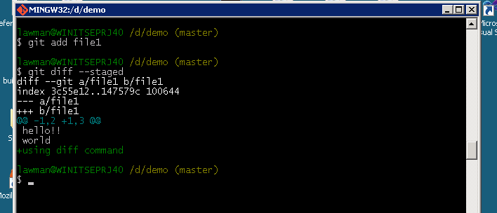
- Git reset
This command is used to unstage the file but preserve the contents of the file.
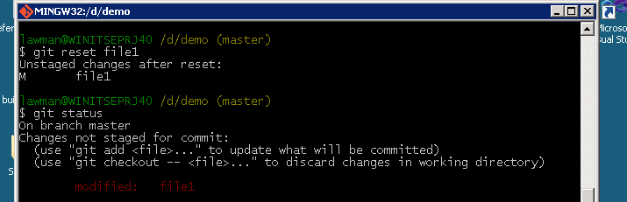
- Git remove and move
The remove command git rm file name are used to delete the file from the working directory and stage the deletion. You can also use option –cached which will remove file from version control but preserve it locally.

The Move command is typically to rename a file and command used is git mv (file original) (file renamed).

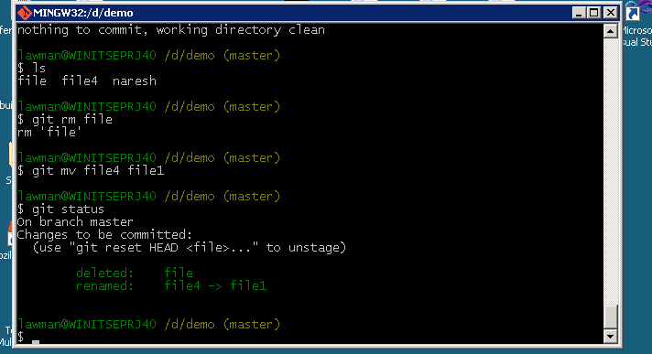
- Git log
This command is used to view the commit history.
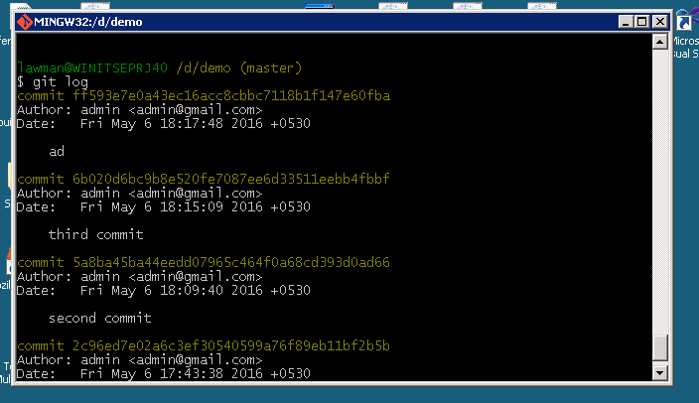
You can also see the 40 digit hexadecimal code being used as checksum.
To view a particular file's history you can use git log –follow (filename)

Branching & Merging
As we know branching can be used for parallel development process and since git supports non linear development as said earlier it is that branches can be created in git and projects can be carried out. The command used is Git branch branchname while git branch alone will lists all your current branches.
To switch to that particular branch you can use the git checkout branchname command.
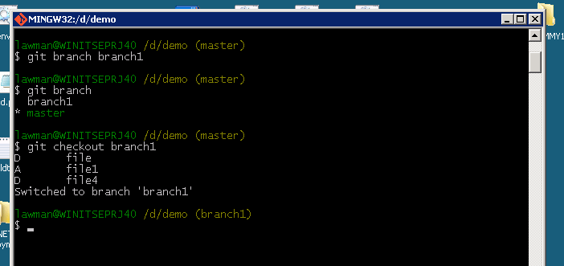
You can see that after switching the name is changed to branch1 from master.

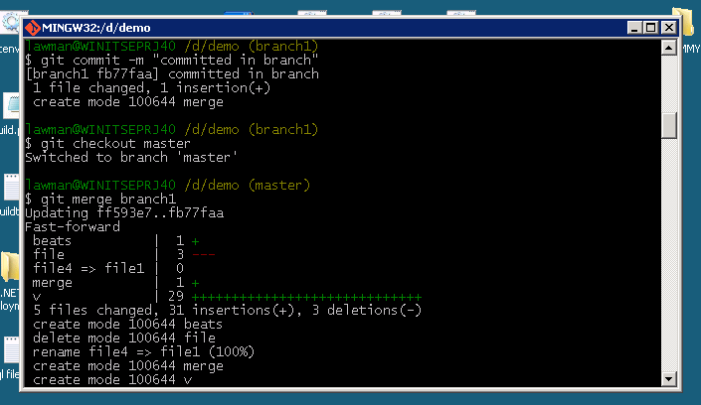
Now lets say I create a file in the branch and make changes to it add and commit the file there in branch. Now if I want to merge it to the master I should switch back to master using git checkout master command then use git merge branchname command.

Thus it is seen that the files committed in branch is being merged to master. Now the word called CONFLICT comes into picture while merging if we try to edit the same file in master and branch and commit it and then if we try to merge it back to master conflict occurs.
This conflict can be resolved by editing the file in vim editor and then saving it and committing it to repo.
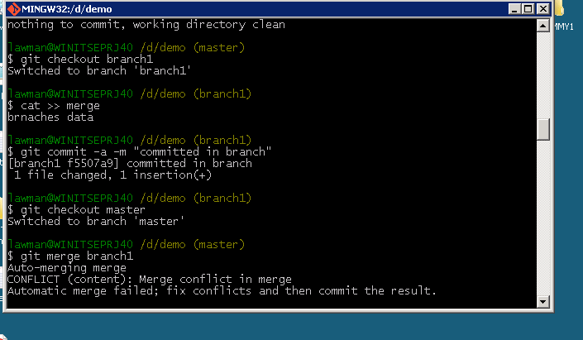
If you open vim file then it will look like this.
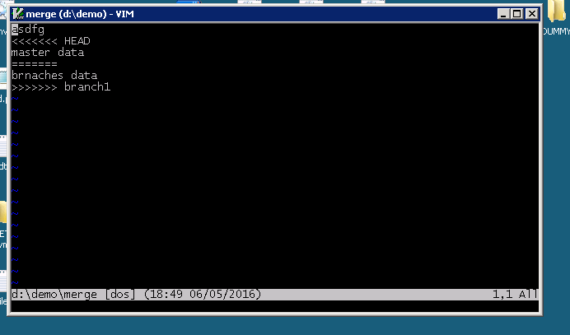

You can open insert mode and then edit the file.
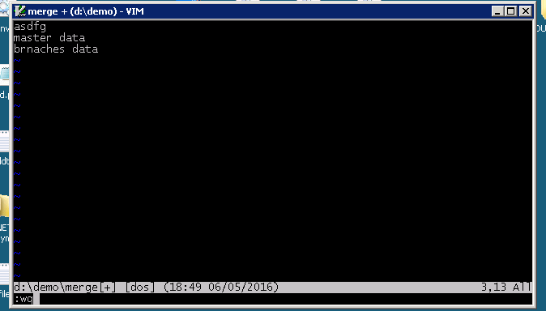
Here I’ve edited to keep both master and branch's data. Save it and close vim then give commit command conflict will be resolved.

FETCH,PULL,PUSH.

There are three more commands involved when it comes to linking your local repository with the centralized or remote repository, they are FETCH,PULL AND PUSH. From the name suggests the commands git fetch and pull are used to update your local repo while the command git push will be used to push your locally made changes to the central repo.

The difference between the fetch and pull is that fetch command gets the stuff from central server and creates a temporary local branch and it needs to be merged using the merge command git merge origin master. Whereas the pull command updates your local repo from central repo automatically without the need of any merging.

The demo is shown below for both fetch and pull commands and the thing here is while pulled there was no new things to merge into my local repository it was up to date that is why warnings were there while if you had anything to merge it will not show such things.

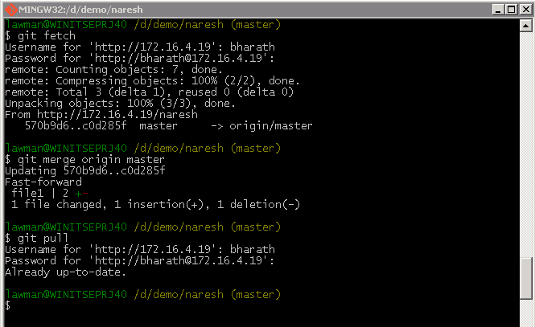
The other command git push is used to push your changes into the central server.
Command used will be git push origin master. The word origin here is the alias name for the server you initially used to clone. While the master determines that up to the latest version or head version to the server.
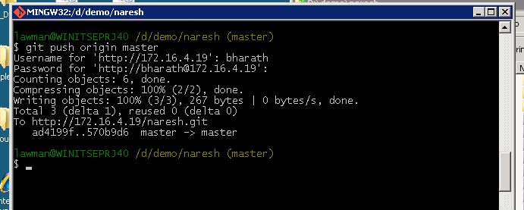

REMOTES
To be able to collaborate on any Git project, you need to know how to manage your remote repositories. Remote repositories are versions of your project that are hosted on the Internet or network somewhere.
To see which remote servers you have configured, you can run the git remote command. it lists the short names of each remote handle you’ve specified. You can also specify -V, which shows you the URLs that Git has stored for the short name to be used when reading and writing to that remote.
Since the CLONE command implicitly adds the ORIGIN remote for you. Here’s how to add a new remote explicitly. To add a new remote Git repository as a short name or alias name you can reference easily, run git remote add <shortname> <url>
You can rename and remove remotes by giving git remote rename remote1 remote2 for rename and for removing git remote rm remote2

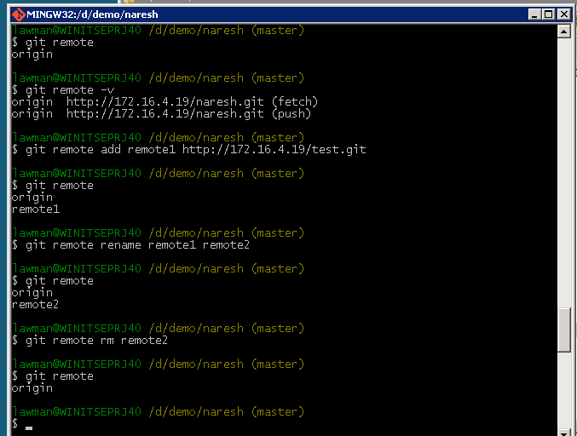

TAGS
Git has the ability to tag specific points in history as being important. Typically people use this functionality to mark release points (v1.0, and so on).
Git uses two main types of tags: lightweight and annotated.
A lightweight tag is very much like a branch that doesn’t change – it’s just a pointer to a specific commit.
Annotated tags, however, are stored as full objects in the Git database. They’re check summed; contain the tagger name, email, and date; have a tagging message; and can be signed and verified with GNU Privacy Guard (GPG). It’s generally recommended that you create annotated tags so you can have all this information; but if you want a temporary tag or for some reason don’t want to keep the other information, lightweight tags are available too.
Lets see about annotated tags first. To create one command git tag -a v1.0 -m “annotated tag”. Then to show tag you can use git show command. To view the tags created git tag command is used.
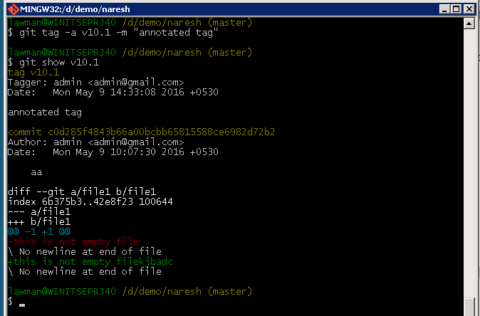

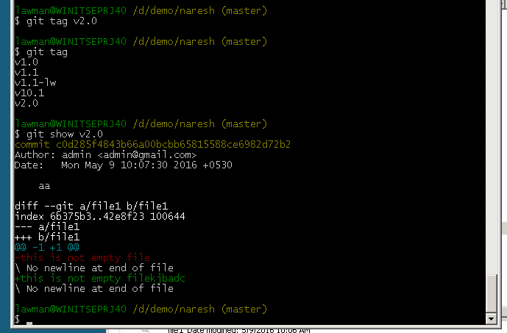
Now we will see about creating lightweight tags and viewing it.

You can also tag later by giving command git tag -a “tagname” commit number.

DISADVANTAGES OF GIT

Some of the disadvantages of git are
- Binary files are a big no because if non-text files are updated frequently such as images for website or Ms office docs then git becomes slow.
- Git cant checkout a sub tree and use it as a complete repository.
- Working with very large projects in git is bit difficult.

